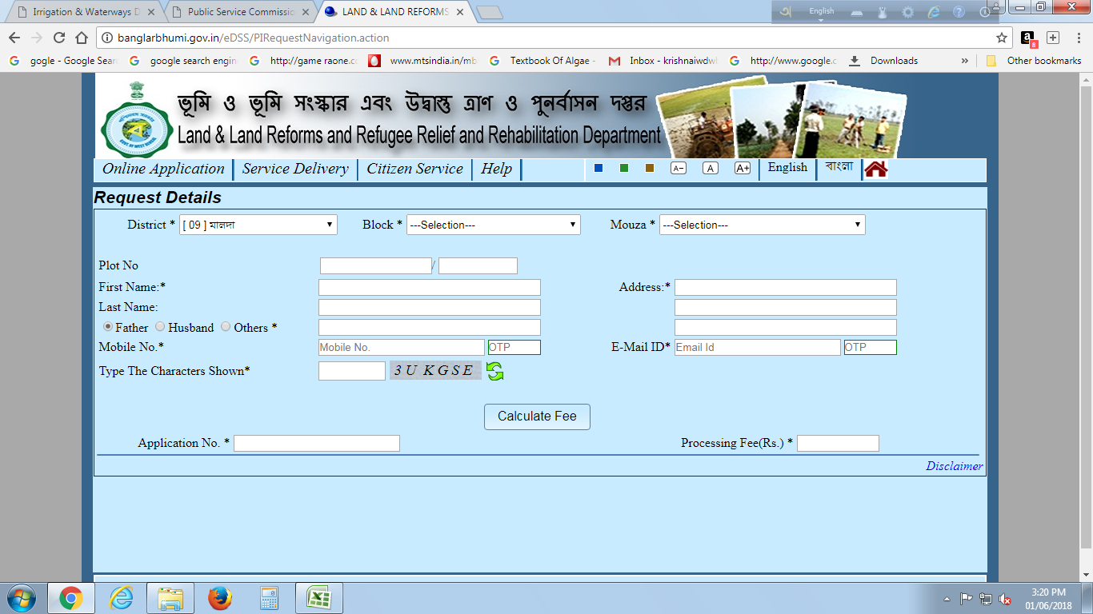

**GOVERNMENT OF WEST BENGAL**

**IRRIGATION & WATERWAYS DIRECTORATE**

**OFFICE OF THE SUB-DIVISIONAL OFFICER**

**BALURGHAT IRRIGATION SUB-DIVISION**

**B.T PARK, BALURGHAT, D/DINAJPUR ,PIN-733101.**

**Memo No.:-22** **Dated : - 07.02.2020**

NOTICE INVITING QUOTATION NO.WBIW/SDO/BISD/NIQ-04/2019-20.

Sealed Quotations are hereby invited by the undersigned on behalf of the Governor of West Bengal, for the work as describe below from eligible bonafide and resourceful agencies/Consultant having sufficient financial capability and credentials for execution of similar nature of work for the following work and on compliance with the under mentioned procedure and terms & conditions. Intending quotationers who desires to participate in the Quotation are requested to log on to the departmental website [www.wbiwd.gov.in](http://www.wbiwd.gov.in) or contact with the office of the Sub Divisional Officer, Balurghat Irrigation Sub-Division, Balurghat, Dakshin Dinajpur for information about the quotation.

|  |  |
| --- | --- |
| **Name of work** | **Time Period** |
| Topographical survey of A.K Gopalan Colony Khari using Total station instrument including submission of editable soft copy , Block&P.S.- Balurghat, District- Dakshin Dinajpur. | 10 (ten) days |

Quotation papers will be issued to the intending quotationers after verifying all necessary papers as per following time schedule

1. Last date of receiving application :- 14.02.2020 upto 4:00 p.m.
2. Last date of issue of quotation :- 18.02.2020 upto 4:00 p.m.
3. Last date of receiving quotation :- 20.02.2020 upto 2:00 p.m.
4. Last Date & time of opening quotations :- 20.02.2020 after 2:30 p.m. (In the chamber of S.D.O/ BISD)

Intending quotationer(s) or his / their representative(s) should remain present at the time of opening of quotations on the schedule date in the office chamber of the undersigned.

**The quoted rates should be inclusive of all taxes/duties all complete.**

Before submitting **Quotation paper**, the intending contractor/bidder should make themselves acquainted thoroughly with the local conditions prevailing at site of implementation of the work by undertaking field inspections and taking into consideration all probable likely factors and difficulties to be involved in execution of the work as per specification in all respects including communication facilities, climate conditions etc. and no claim whatsoever will be entertained on those accounts afterwards. He/She may contact this office in any working day in between 11 am to 3 p.m. intending agencies or their authorized representatives may remain present while opening of the sealed covers containing quotation.

Selection of appropriate Agency is entirely vested upon the Quotation-cum-Bid Evaluation Committee

(QBEC). The committee reserves the right to accept or reject any or all quotation without assigning any reason there of Since.

The intending agencies should submit the following and self-attested copies of the same are to be

Submitted with the Application.

i) Credential Certificate:-

BOQ duly authenticated by issuing authority and work order.

Completion Cer t i ficate of 100% completed work of similar nature.

ii) Annual Turnover from business:-

Profit and loss accounts statement in the prescribed form with annual turnover of last three financial years or during the period since formation of the company/ Firm/society, if it was set up in less than three year period.

iii) Company Details like Trade license and others documents.

iv) Professional Tax Payment Certificate (PTPC) or Challan.

v) PAN Card.

vi) GST Registration Certificate

Sub-Divisional Officer

Balurghat Irrigation Sub-Division

Balurghat, DakshinDinajpur

***Memo No. 22(6) Date:-07.02.2020***

Copy Submitted for information and wide circulation: (1) Superintending Engineer, North Irrigation Circle - I, Greenpark, Malda.

(2) Executive Engineer, South Dinajpur Irrigation Division, Balurghat.

3) District Information & Cultural Officer, Balurghat, DakshinDinajpur.

4) S.D.O.,Gangarampur Irrigation Sub-Division, Buniadpur

5) Accounts Branch of South Dinajpur Irrigation Division.

6) Estimating Section of South Dinajpur Irrigation Division.

6) Notice Board of this Sub -Division.

Sub-Divisional Officer

Balurghat Irrigation Sub-Division

Balurghat, DakshinDinajpur

Issued to :- …………………………………………………………………

NIQ No- :-…………………………………………………………………

Name of Work :- Topographical survey of A.K Gopalan Colony Khari using Total station instrument including submission of editable soft copy , Block&P.S.- Balurghat, District- Dakshin Dinajpur.

|  |  |  |  |  |  |
| --- | --- | --- | --- | --- | --- |
| ***Sl. No.*** | ***Particulars*** | ***Quantity (No.)*** | ***Unit*** | ***RATE INCLUDING CESS & GST***  ***( in Rupees)*** | ***Amount***  ***( in Rupees)*** |
| 1 | **Field Work :** Electronic data recording by TOTAL STATION (A modern computerized topographic survey instrument) of the following objects in the project area : 1. Long section of the channel at a stretch of 0.8 km showing the HFL, bed level, both side bank level. 2. Cross section of the channel - @ 30 m (approx) interval in 0.8 km stretch.  3. Marking of temporary bench mark (TBM) in suitable location.  **Office work** :  a) Down loading the recorded data from TOTAL STATION to computer.  b) Conversion of data from EXCEL to AUTO CAD.  c) Preparation of details drawing by AUTO CAD.  d) Submission of six copies Drawing as per the direction of Engineer in charge.  N:B :- the rate is inclusive of all charges & taxes. | 1 | Job |  |  |

Signature of Agency

Sub-Divisional Officer

Balurghat Irrigation Sub-Division

Balurghat, DakshinDinajpur