W.B.F. No. – 2914 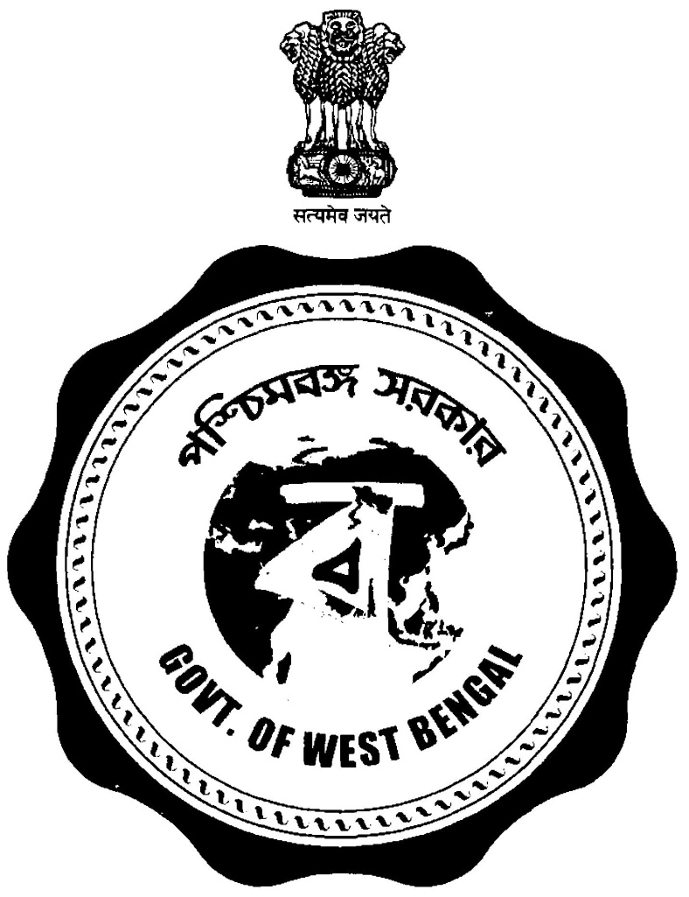
Government of West Bengal
Irrigation & Waterways Directorate
Office of the Sub-Divisional Officer
Kangsabati Canals Sub-Division No XVIII
Bankura
Memo No : 240 Date : 24.07.2025

Corrigendum No 01 of NIT No. 02/K.C.XVIII OF 2025-2026.
Due to type mistake in schedule of work rate of NIT No. 02/K.C. XVIII of 2025-2026 will be as follows :-

As per Main NIT :

1 | RATE Including GST & Cess (Rs.) | S.D.O/ K.C.Sub-Divn. No. XVIII, Bankura.

To be read as :

1 | RATE Including Cess 1% (Rs.) | S.D.O/ K.C.Sub-Divn. No. XVIII, Bankura.

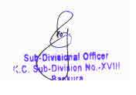

Memo No : - 240/1(8) Dated:- 24.07.2025

Copy for information & wide Circulation to the:-
- Superintending Engineer, Kangsabati Circle - I, I & W Dte. Bankura
- Executive Engineer, Bankura Irrigation Division, Bankura
- Sub- Divisional Officer. /K.L.BSub Division No-V, .Bankura .
- Sub- Divisional Officer. /B.I. Sub-Division ,Bankura
- Sub- Divisional Officer. /K.C.S.D. No.-VI ,Taldangrara .
- Sub- Divisional Officer. /V.I. Sub Division, .Bishnupur .
- Office Notice Board/ Divisional Accounts Officer / Estimating Section /Hd. Clerk / Cash Section of Bankura Irrigation Division, Bankura.
- Office Notice Board of K.C. Sub-Division No.XVIII

